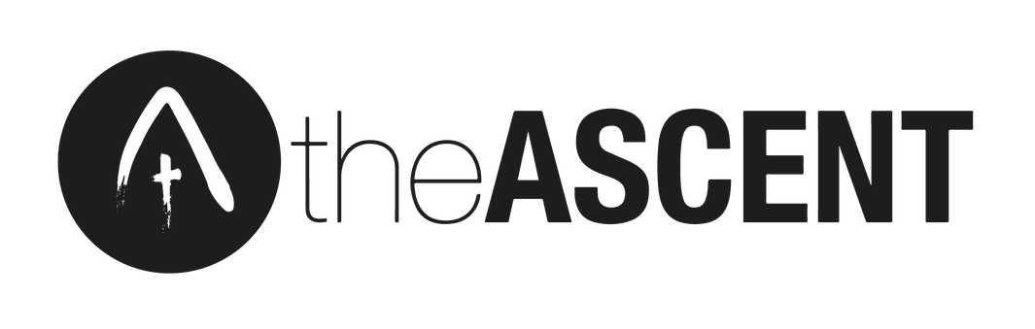
Consent Form
Please complete the information on this page of the form and then read the bottom section of page two and three before signing the declarations on page four (participants) and five (parents/guardians).
Once completed, please email it to admin@theascentuk.co.uk This form is CONFIDENTIAL.

ABOUT THE PARTICIPANT

FULL NAME:

MALE/ FEMALE (please delete one)
KNOWN AS: |  | DATE OF BIRTH:
MOBILE NUMBER: |  | HOME PHONE NUMBER:
EMAIL ADDRESS: |  | HOME ADDRESS:
PLEASE PROVIDE THE NAME AND CONTACT DETAILS OF A PARENT/ GUARDIAN, INCLUDING A NUMBER FOR USE IN EMERGENCIES:

Some important regulations and things to note:
ABOUT THE PARTICIPANT (cont.)
DO YOU HAVE ANY DIETARY REQUIREMENTS, MEDICAL CONDITIONS, OR ANYTHING ELSE WE NEED TO BE AWARE OF SO THAT WE CAN LOOK AFTER YOU PROPERLY? FOR INSTANCE, ANY RECENT TRAUMAS OR BEREAVEMENTS? OR ANY DIFFICULTIES YOU ARE CURRENTLY GOING THROUGH? PLEASE ALSO DESCRIBE ANY MEDICATION YOU ARE TAKING AND WHETHER YOU WILL NEED ASSISTANCE IN STORING OR TAKING IT.

The site rules for theASCENT process are available on our website. theASCENT team is there to enforce these rules and may ask you to change your behaviour, especially if they think there is a risk to other people.

If you do not comply with the site rules, theASCENT team may ask you to leave the site. In such cases, it will be the responsibility of your parent/ guardian to facilitate transport, hence they must remain contactable throughout the weekends, and all other meetings.
During theASCENT process, your booking may be cancelled or you may be asked to leave the process at any time at our discretion. In this scenario you will have to still pay the remainder of the year’s fee.

cont. overleaf...

Some important regulations and things to note (cont.)
Proselytising

theASCENT is committed to giving delegates freedom in what they choose to listen to and be influenced by. We will not tolerate proselytising at our events.

theASCENT understands proselytising to be:
Manipulative attitudes and practices that exploit people's needs, weaknesses or lack of education especially in situations of distress.
Comparing two communities by unevenly emphasising the achievements and ideals of one against the weaknesses and practical problems of the other.
Making unjust or uncharitable references to beliefs and practices and even ridiculing them.
Employing any kind of physical violence, moral compulsion and psychological pressure. Using political, social or economic power as a means of winning new members for a religion.
Extending explicit or implicit offers of material inducements, education or health care or using financial resources with the intention of making converts.

theASCENT’s liability

We put as much information as we can on our website for guidance but we can't guarantee that the information is always accurate or up to date. The website and anything we describe on it may change without notice, including information about the process. We will not be liable for any damage or loss caused as a result of your doing, or not doing, anything as a result of using our website.

We do not guarantee that the website will be compatible with all hardware and software which you may be using to access the site. We will not be liable for damage (e.g. computer viruses) to your computer or other property as the result of your use of this website.

The website, its design, layout, look, appearance and graphics is our property. Because of copyright you may only download, print, or copy any part of the website for personal use.

Website problems
Although we will do our best to provide constant, uninterrupted access to theascentuk.co.uk, we do not guarantee this. We accept no responsibility or liability for any interruption or delay.

Changes to these terms
These terms and conditions may be changed from time to time to keep you up to date with our policies. Please ensure that you review these terms and conditions regularly. By continuing to use the site, you agree to any changes made to the terms and conditions.

FOR THE PARTICIPANT:
Please read through each box and sign if you agree.

SIGNATURE DATE
PARTICIPANT’S consent

I agree to take a full part in theASCENT, to abide by its rules, and to respect other participants. I understand that failure to do so may result in my removal from theASCENT with loss of money’s already paid and potential liability for the rest of the year’s fees. I affirm that the information given in this form is correct to the best of my knowledge. I understand and agree to the terms and conditions noted on the Standing Order & Deposit Form. I understand that theASCENT will store the data on this form for the duration of the process and for the purpose of properly looking after me and administering the process. I understand that theASCENT will use my data to contact me regarding the arrangements of the process.

SIGNATURE DATE
PARTICIPANT’S consent to photos and videos

I understand, and agree with, the fact that photo and video will be taken by theASCENT during weekends and other activities. I understand that such material will be stored by theASCENT and used for the purposes of future publicity. I understand that it is my responsibility to let those taking photos or video know if I do not wish to be included. I understand that theASCENT is not responsible for photos and video taken by third parties, including other participants.
PARTICIPANT’S consent to the use of data

I give theASCENT consent to store my home address, phone numbers, and email address both during and after the process and to use that data to inform me of any courses, programmes, resources, events, or other opportunities, provided by theASCENT, CREW and others, which theASCENT believes may be useful or interesting to me.

SIGNATURE DATE

PARENT’S consent

I give permission for my child to take part in theASCENT process, which I understand will last three years, will involve three residential weekends per year and other meetings, as well as weekly online ‘PoDs’, as well as online mentoring and other activities, as detailed on www.theascentuk.co.uk.

I affirm that the information given in this form is correct to the best of my knowledge.

I understand that certain standards of behaviour are expected and that participants can be removed from the process or from individual weekends and other events at the discretion of the organisers. I understand that in such cases it will be my responsibility to facilitate transport.

I understand that I must remain contactable throughout weekends and other events and that I must provide the organisers with all the relevant information they need to properly look after my child.

I give permission for theASCENT leaders to make emergency medical decisions and to authorise treatments and procedures on my behalf should it be necessary in the event of my being unreachable. I agree to the terms and stipulations noted in the Standing Order & Deposit Form and in the parents’ information sheet.

SIGNATURE DATE

PARENT’S consent to photos/videos and the use of data

I understand, and agree with, the fact that photo and video will be taken by theASCENT during weekends and other activities. I understand that such material will be stored by theASCENT and used for the purposes of future publicity. I understand that it is my child’s responsibility to let those taking photos or video know if he/she does not wish to be included. I understand that theASCENT is not responsible for photos and video taken by third parties, including other participants.

I give theASCENT consent to store my child’s home address, phone numbers, and Email address both during and after the process and to use that data to inform him/ her of any courses, programmes, resources, events, or other opportunities, provided by theASCENT, CREW and others, which theASCENT believes may be useful or interesting to him/her.

SIGNATURE DATE

